Задание 1: Грамматика: в учебнике изучить правило употребления Модальных Глаголов (скриншоты ниже), законспектировать в рабочую тетрадь (выписать глагол и его значение, привести примеры). Выполнить Ex.5 на странице 201 (восполнить пропуски, текст переписывать не надо).

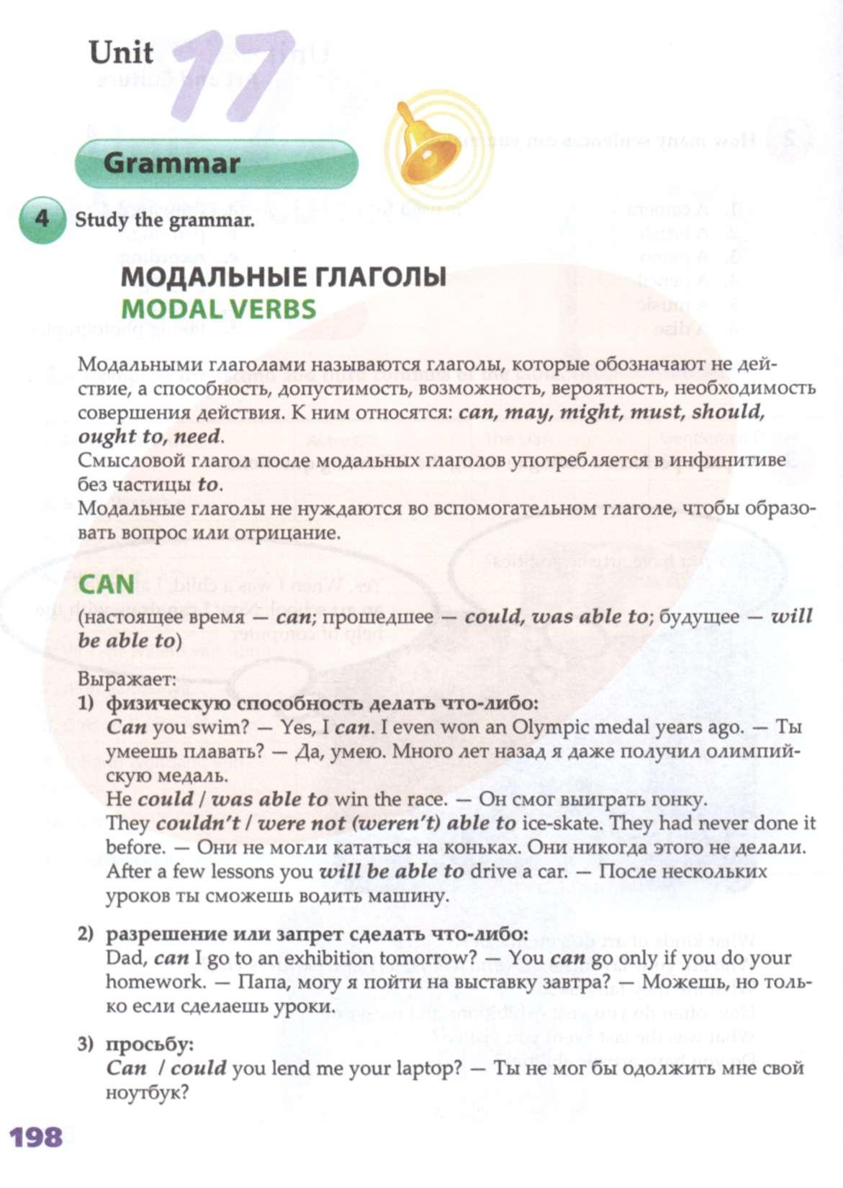

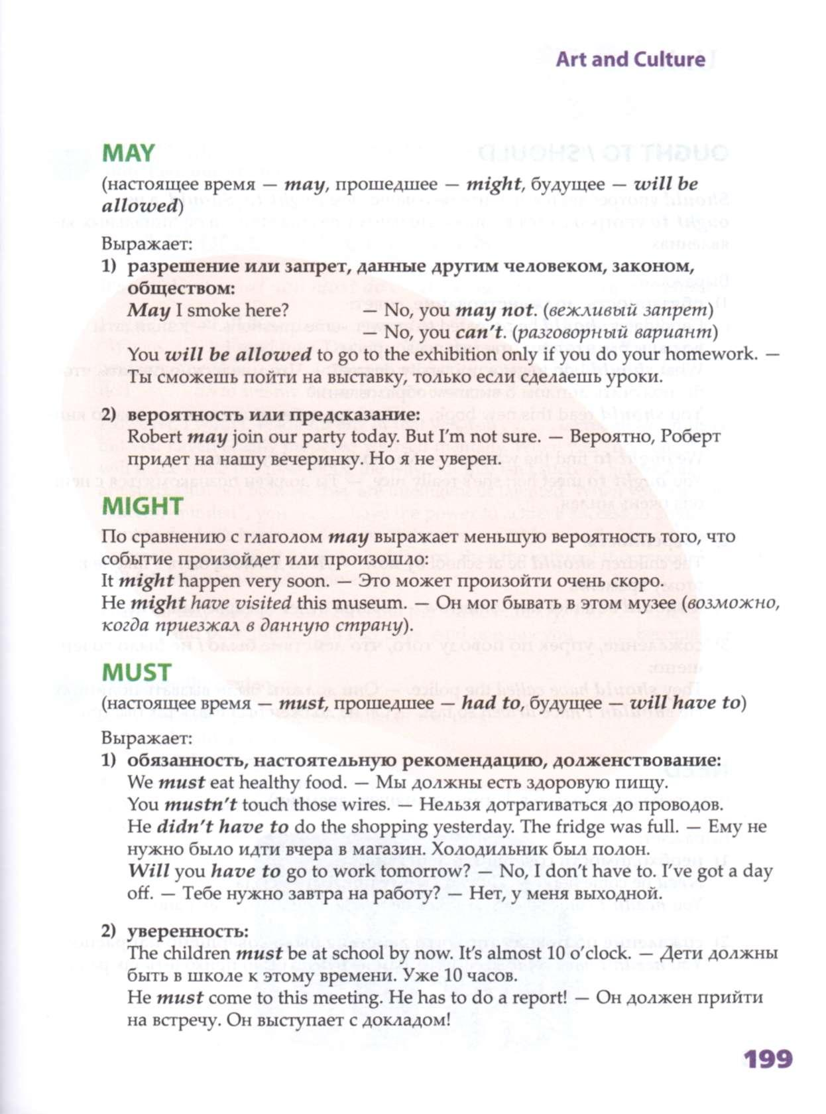

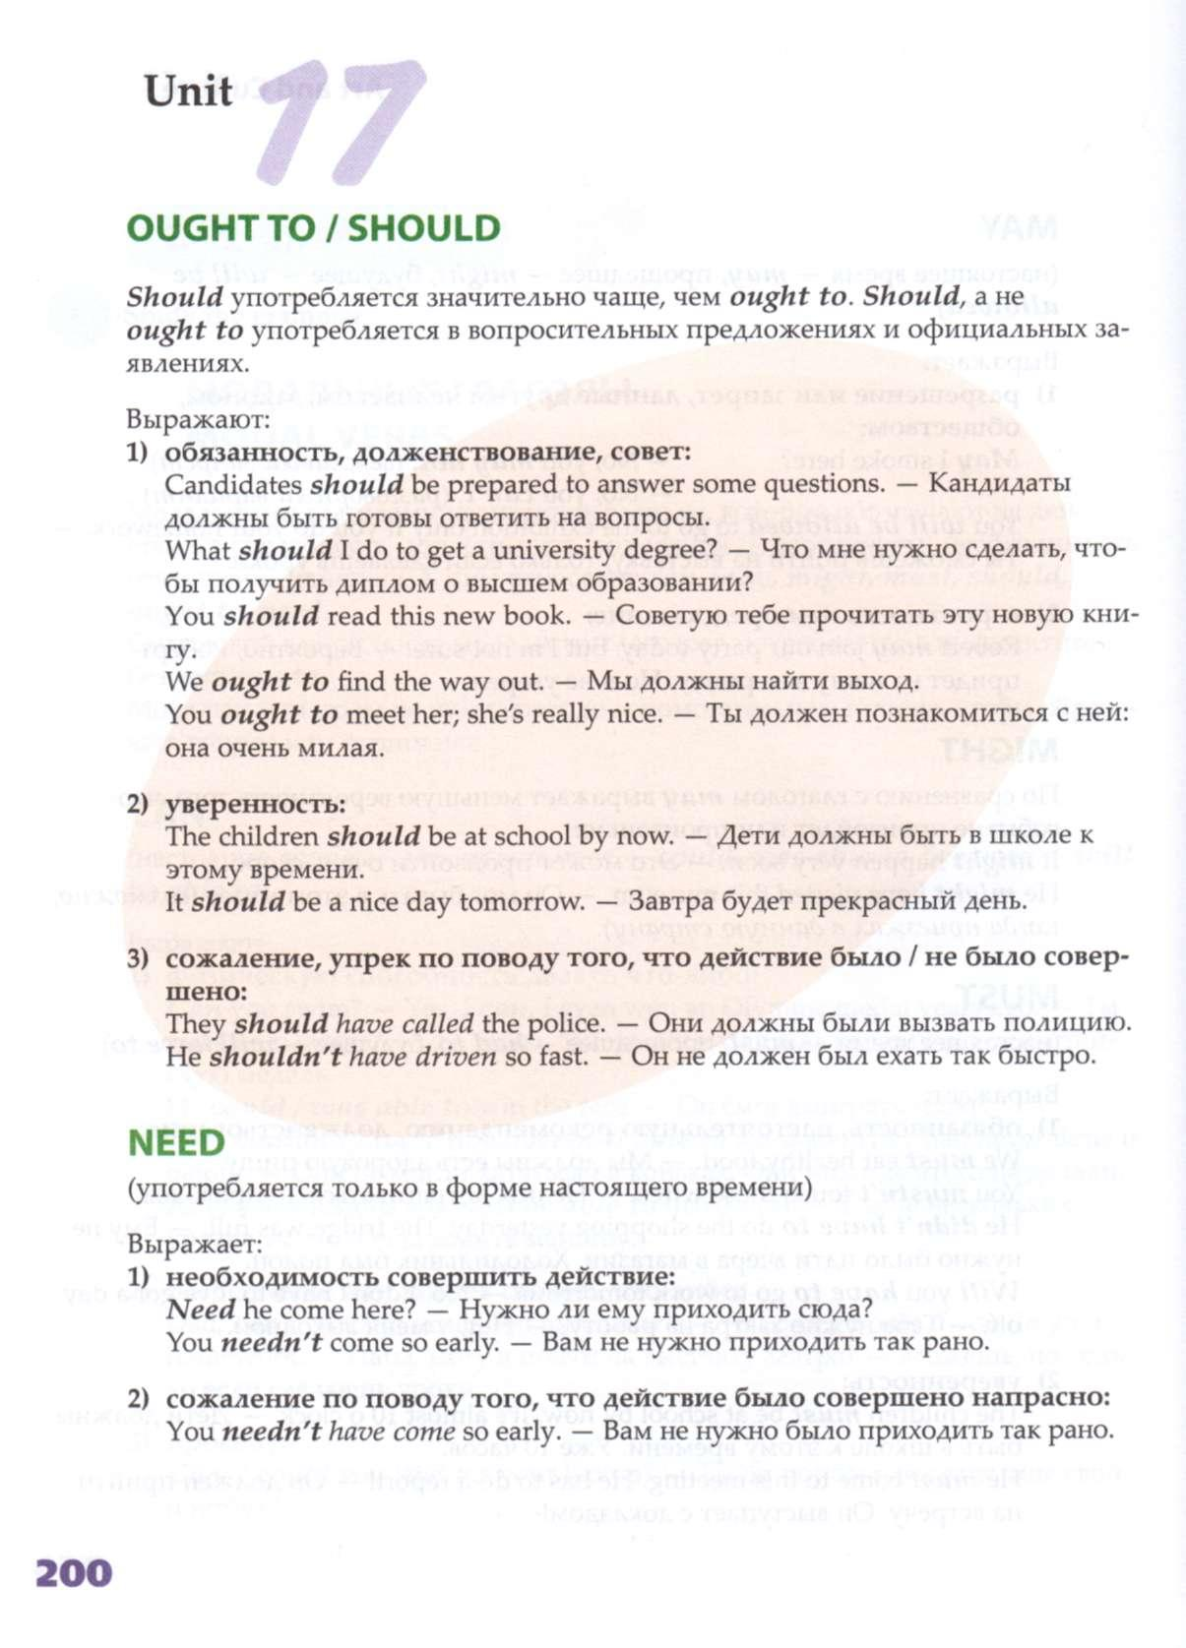

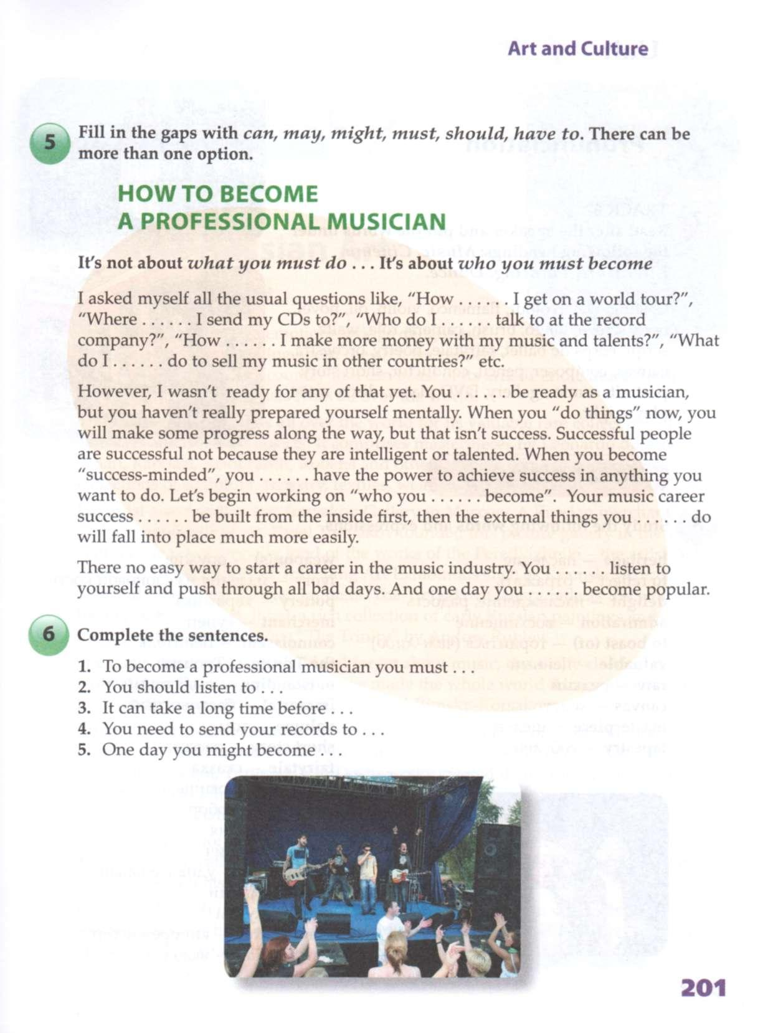

Задание 2: Прочитать текст и выписать выделенные слова с переводом и транскрипцией (Active vocabulary). Ответить на вопросы:

What is the main topic of this text?
How would you title the text?
Do you like sports?What is your favourite kind of sport?

All over the world people of different ages are very fond of sports and games. Firstly, sport helps people to become strong and to develop physically. Secondly, it makes them more organized and better disciplined in their daily activities. Also sport keeps your mind healthy. Sport helps people to keep in good health. We all need to exercise. Regular exercises give you more energy. Exercises make you feel and look better. The best exercises are: walking, jogging or swimming. Among the sports popular in our country are football, basketball, swimming, volley-ball, ice hockey, tennis, gymnastics, skiing, figure skating. A person can choose sports and games for any season, for any taste.
As for me, I like sport. I like tennis, swimming, basketball, football, valley-ball. But my favourite sport is football. Of course, I buy the sports magazines and newspapers, for example: "Sport Express", or "World soccer". I like football in our country, because I live in Russia, but Spanish Premier League I like more. However, I think our football is not less strict and beautiful. By the way football is a team kind of sport. It is a sport played between two teams of eleven players with a spherical ball. The object of the game is to score by driving the ball into the opposing goal. In general play, the goalkeepers are the only players allowed to touch the ball with their hands or arms, while the field players typically use their feet to kick the ball into position. The team that scores the most goals by the end of the match wins. If the score is tied at the end of the game, either a draw is declared or the game goes into extra time or a penalty shootout, depending on the format of the competition. I like this game because it is beautiful, interesting and really fast. Perhaps that's why football is so popular nowadays.
Talking about whether I would watch some sport competitions on TV or participate in it I would say that watching them on TV is fine but personally I would of course try to participate in some sport activities since it's much funnier than just watching it. Also it will help me to keep my body in a good shape and to keep me fit and energized.

Active vocabulary:
daily activities [ˈdeɪli ækˈtɪv.ɪ.tis] повседневная деятельность
exercise [‘eksəsaɪz] упражнение, тренировка
walking ['wɔ:kɪŋ] ходьба
jogging ['ʤɔgɪŋ] бег
swimming [‘swɪmɪŋ] плаванье
football [‘futbɔ:l] футбол
basketball [‘bɑːskɪtbɔːl] баскетбол
volley-ball [ˈvɒl.i.bɔːl] волейбол
ice hockey [‘aɪsˌhɒkɪ] хоккей
tennis [‘tenɪs] теннис
gymnastics [dʒim’næstiks] спортивная гимнастика
skiing [‘ski:ɪŋ] катание на лыжах
figure skating [ˈfɪɡə(r) skeɪ.tɪŋ] фигурное катание
team [ti:m] команда
player [‘pleɪə] игрок
to score [skɔ:] засчитывать, забивать
goalkeeper ['gəulˌkiːpə] вратарь
the field players игроки на поле
match [mæʧ] матч
to win [wɪn] выигрывать, побеждать
to kick [kɪk] бить по мячу
extra time дополнительное время
competition ['kɔmpɪ'tɪʃ(ə)n] состязание
penalty [‘penltɪ] пенальти
soccer [‘sɔkə] футбол

Задание 3: Написать мини-эссе на тему: «Роль спорта и здорового образа жизни в наше время» (7-10 предложений). Обратить внимание на структуру: вступление, основная часть, заключение. Желательно использовать лексику из предыдущего задания.

